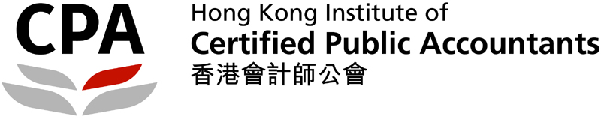
To: The Management
Hong Kong Institute of Certified Public Accountants
27/F, Wu Chung House
213 Queen’s Road East
Wanchai, Hong Kong

(Fax No.: 2147 3293 or email: theresachoi@hkicpa.org.hk)

Reply Slip
(Deadline: 4 September, 2015)

Outstanding BAFS Student Awards 2015

I, _________________ _ _____ (Name), ___(HKID), confirmed that:
(Surname First, Block and in Full)

(please indicate with a “✓”)
❑ my name printed on the list of awardees is correct

❑ my name printed on the list of awardees is incorrect

(the payee name should be _______________________________________).

Please mail the cheque to me to the following address: (English in block letters)

Signature:
Contact no.:
Date:

