Acquire/Forget International Affiliates Login ID and Password

You need to access ‘Forget Login ID / Password (International Affiliates)’ screen to retrieve your Login ID and Password if you acquire or forget Login ID and Password, click the link below:
http://www.hkicpa.org.hk/login/getloginpwd/getloginpwd.php?itemfrom=iaonly
or you may follow the steps to get your Login ID and Password below.

Step 1:
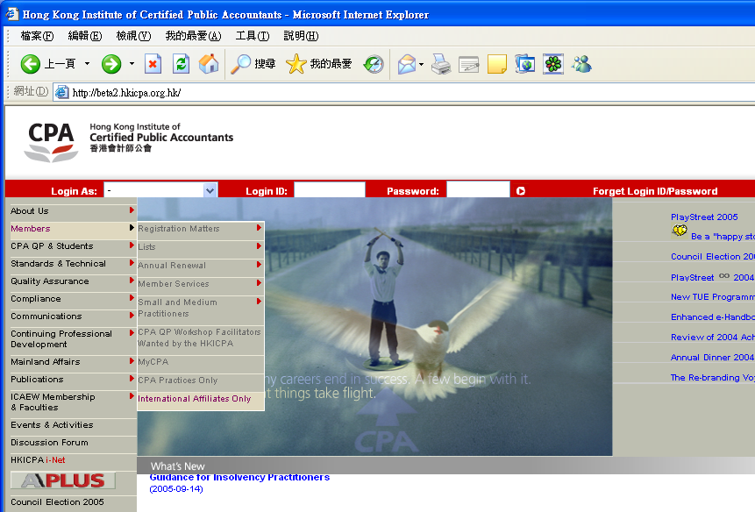
Select ‘Members‘ from the main-menu.

Click ‘International Affiliates Only’ from the first ‘slide-out’ menu.

Step 2:
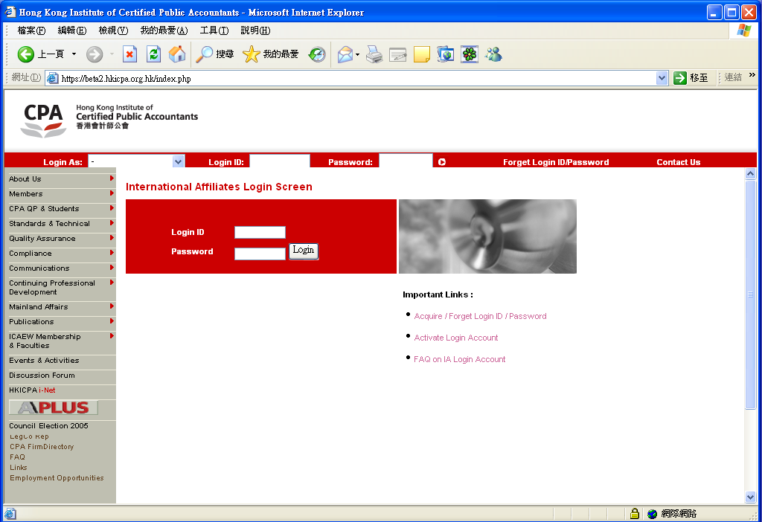
Select ‘Acquire / Forget Login ID / Password’

Step 3:
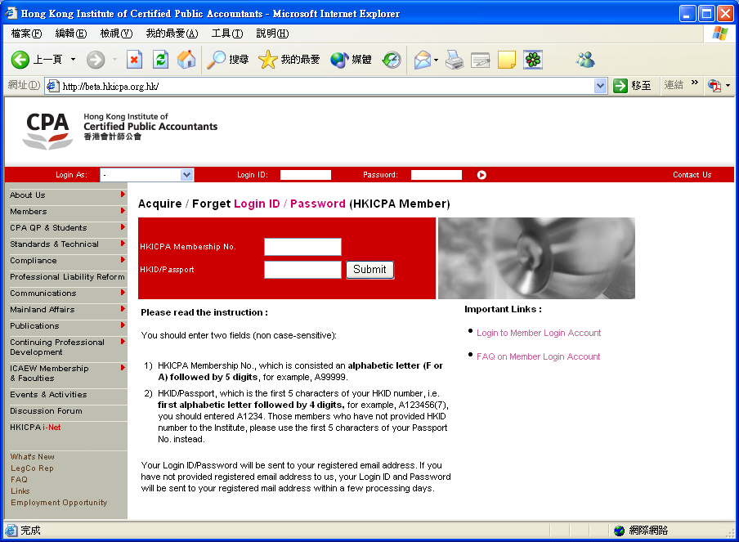

- Enter your “HKICPA IA Reg No.”
- Enter the first 5 characters of your HKID number. Those International Affiliates who have not provided HKID number to the Institute, please use the first 5 alphanumeric characters of your Passport number instead. (e.g. A1234).
- Click the “Submit” button

Step 4:

If International Affiliate has a registered email address, corresponding Login ID and Password will be sent to International Affiliate’s registered email address automatically.

If International Affiliate has no registered email address, corresponding Login ID and Password will be sent to International Affiliate’s registered correspondence address by mail. It takes approximately 3 working days to process.

For those International Affiliates who already have approved Login ID or pre-assigned Login ID, but have not yet activated their login account. Only Login ID will be sent to International Affiliate. For detail instructions, please refer to the section below: How to activate International Affiliate Login Account.

International Affiliates can also change their Login ID through ‘Change Login ID / Password’ under the International Affiliates Only section. For detail instructions, please refer to the section below: How to change International Affiliate Login ID and Password’.

How to activate International Affiliates Login Account

To access ‘International Affiliates Login Account Activation Screen’, click the link below:
http://www.hkicpa.org.hk/login/activatelogin/activatelogin.php?itemfrom=iaonly
or you may follow the steps to activate your login account below.

Step 1:
Select ‘Members’ from the main-menu.

Click ‘International Affiliates Only’ from the first tire ‘slide-out’ menu.

Step 2:
Select ‘Activate Login Account’

Step 3
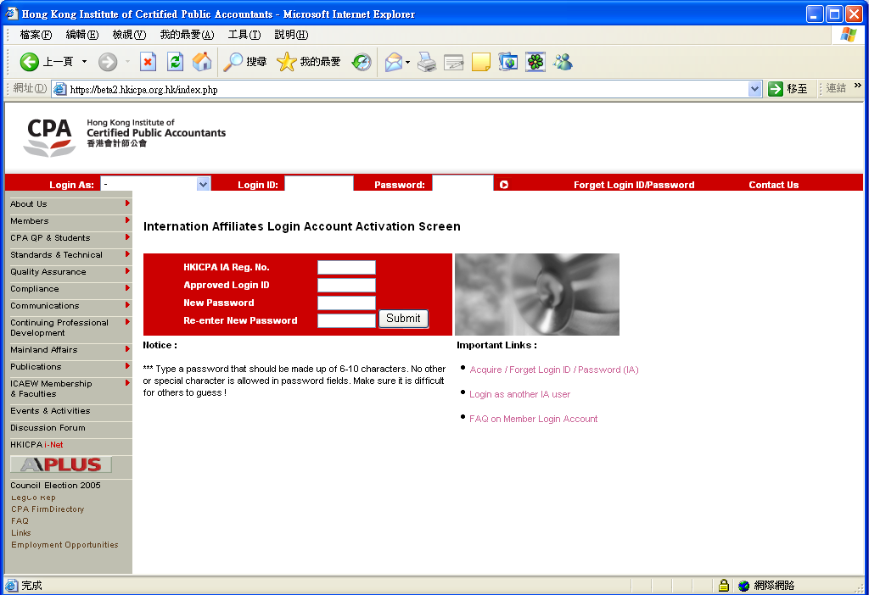
- Enter your IA Reg. No. that begins with “IA” followed by 5 digits. (Non case-sensitive). For example: IA0099.

- Enter your approved Login ID which is pre-assigned by HKICPA.

International Affiliate has to enter his/her own password to the boxes of ‘New Password’ and ‘Re-enter New Password’.
(Remember: The content of ‘New Password’ must be the same as the content of ‘Re-enter New Password’.)
Click ‘Submit’ button.

Step 4:
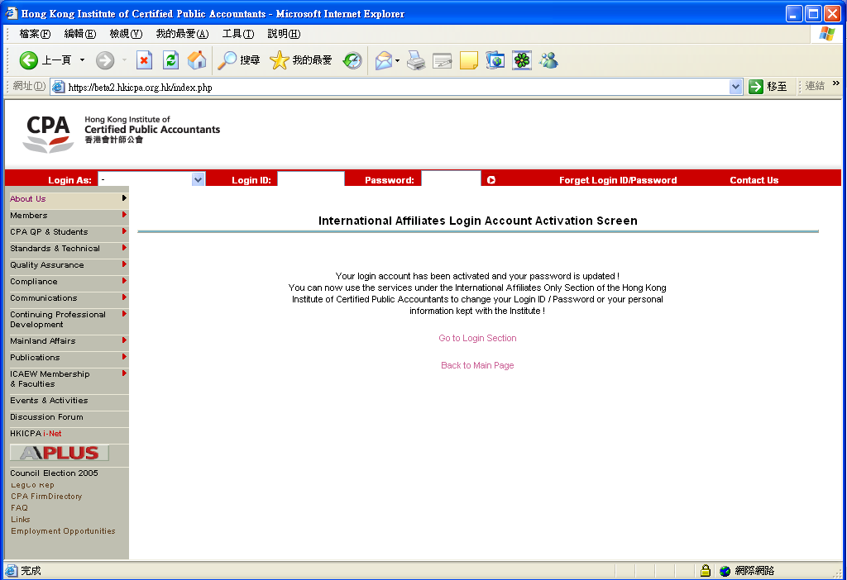
A successful message is shown on the screen; you can click the link to login to the International Affiliates Only section.

How to change International Affiliates Login ID and Password

To access ‘Change Login ID / Password Screen’, you need to login to the International Affiliates Only section, click the link below to login:
http://www.hkicpa.org.hk/login/login.php?itemfrom=iaonly

or you may follow the steps to change your Login ID and Password below.

Step 1:
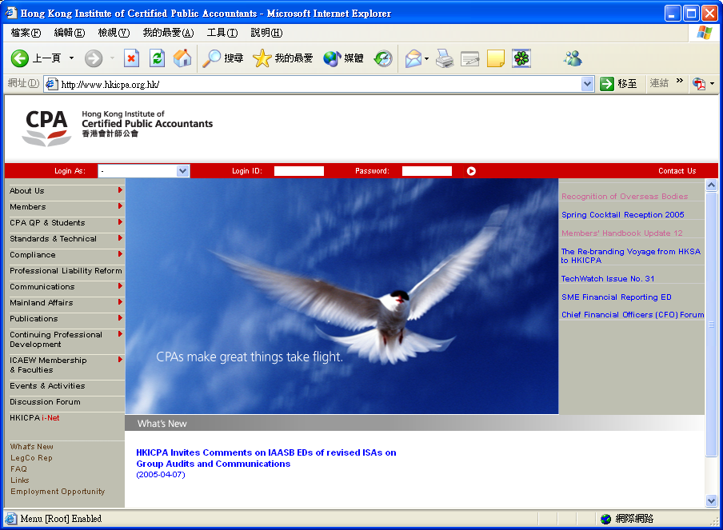
- Select ‘IA Member’ from the ‘Login As’ drop down menu.
- Enter your Login ID and Password.
- Click the button.

Step 2:
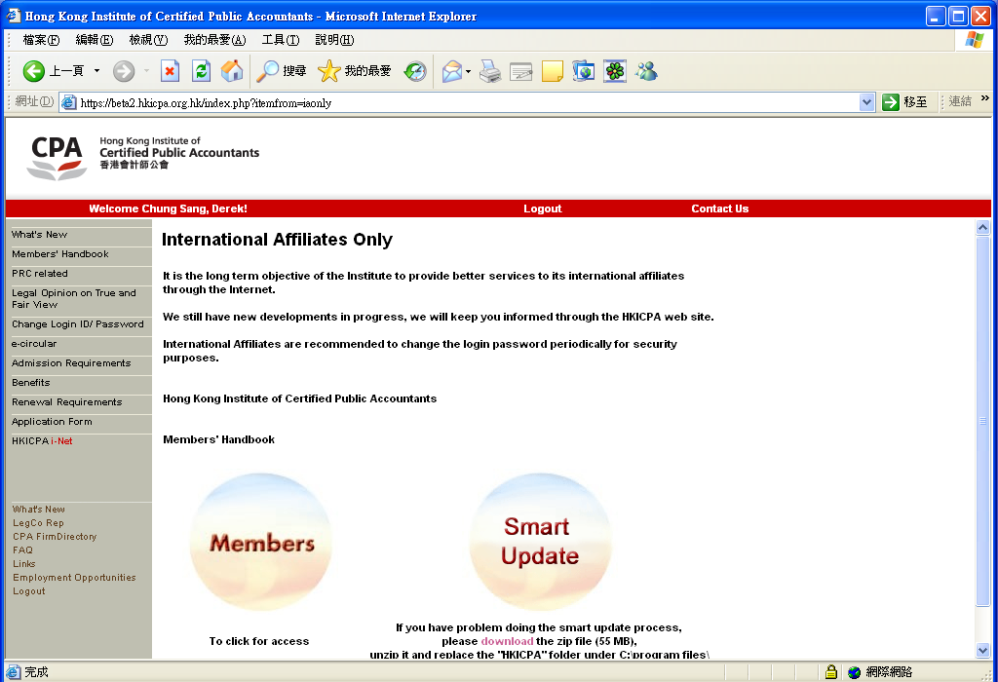

Click the ‘Change Login / Password’ on the sidemenu.
Step 3:
You can change either your Login ID or your Password independently or change both Login ID and Password at the same time. Simply fill out the boxes. You must enter your old password to proceed your request and click 'Submit' button to confirm your request.

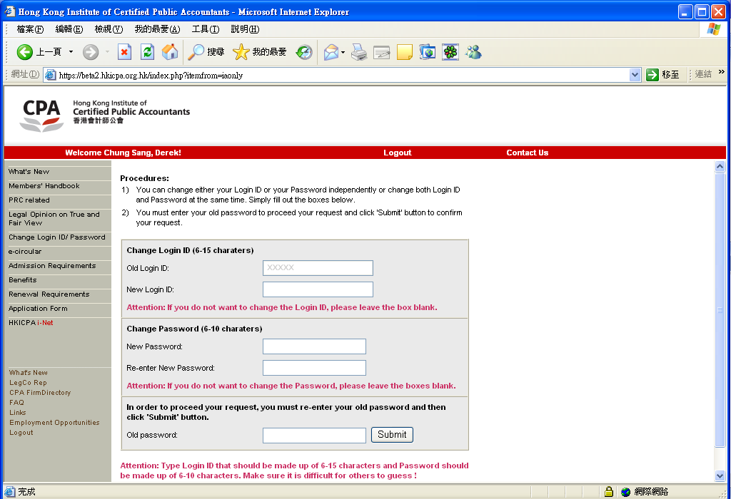
- If you want to change Login ID, fill out the ‘New Login ID’ box.
- If you want to change password, fill out the ‘New password’ and ‘Re-enter New Password’ boxes.

You must provide old password in order to process your request in ‘Old password’ box.
Click ‘Submit’ button.

Attention: Type Login ID that should be made up of 6-15 characters and Password should be made up of 6-10 characters. It may contain numbers (0-9), uppercase or lowercase letters (A-Z, a-z), underscore ( _ ) only. No other special character is allowed in Login ID and Password fields. Make sure it is difficult for others to guess!

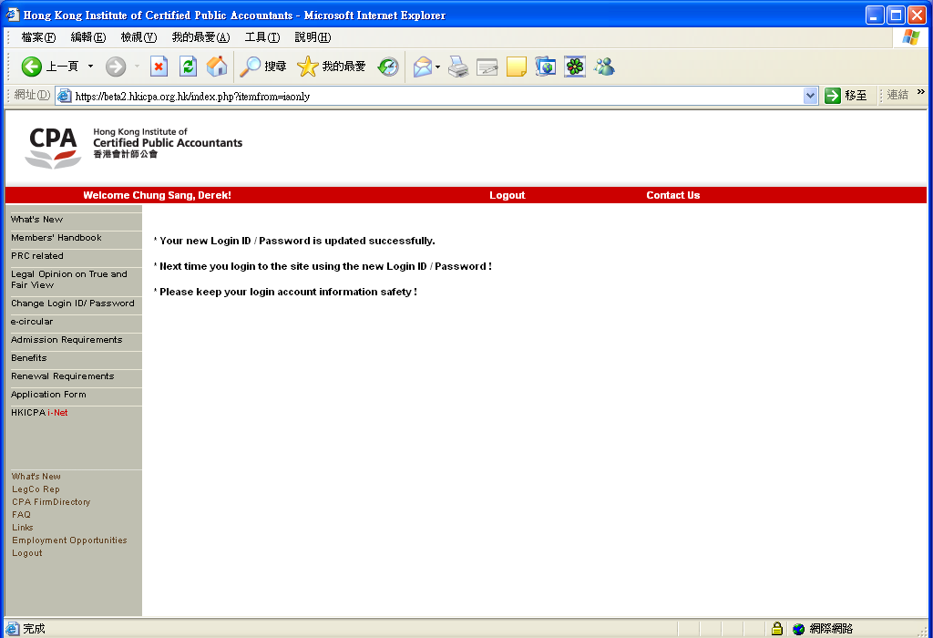
Step 4:
A successful message is shown on the screen.

